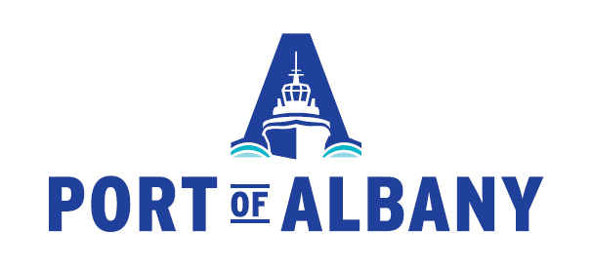

ALBANY PORT DISTRICT COMMISSION
MINUTES OF A REGULAR MEETING
JUNE 17, 2019

Chairwoman Steffens called the meeting to order. In attendance were Commissioners Coffey and Tagliento. Also present were CEO Hendrick, General Counsel Jordan, Economic Development and Procurement Director Daly, Director of Security Williams, Assistant Director of Security Teller, Lynn Zeronda (CFO For Hire), Steve Boisvert (McFarland Johnson, Inc.) and Administrative Assistant Gaspary.

Chairwoman Steffens introduced the minutes of the May 14, 2019 Commission meeting. No changes were made to the minutes. Chairwoman Steffens called for a motion to approve the minutes of said meeting. A motion was made by Commissioner Tagliento, seconded by Commissioner Coffey and passed unanimously.

CEO UPDATE

CEO Hendrick updated the Board on the following:
- Port Industry Day was a success. Attendance was high, the Port tours went well, and the feedback was very positive.
- CEO Hendrick spoke with Ardent Mills regarding the progress and possibilities of the south wharf reconstruction. Ardent Mills has renewed interest in the offloading platform to import grain by ship.
- The Port’s most recent Annual Report is now available and the Port’s new website was launched last week.
- The position of CFO has been advertised in the Times Union and on the websites of the Center for Economic Growth and the Capital Region Chamber as well as on the Port’s website.

FINANCIAL UPDATE

Lynn Zeronda updated the Commissioners as to the financial work being done, specifically the forecasting and cash flow tools and updated on the request submission made to ESD for the $4 million in grant proceed reimbursement for the Big Lift Warehouse.

PORT EXPANSION UPDATE

Director Daly and Steve Boisvert of McFarland Johnson provided an update on the status of the 80 acres and required reporting submitted to the Town of Bethlehem with anticipated completion in very early fall.

MARITIME BUSINESS ASSESSMENT

CEO Hendrick provided an overview of the Ships, Barges and Tonnage Report and Longshore Hours Report for May 2019.

OTHER BUSINESS

No other business for discussion.

PUBLIC COMMENT

No public comments were made.

EXECUTIVE SESSION

Chairwoman Steffens called for a motion to enter into Executive Session for a discussion on the proposed acquisition, sale of real property. A motion was made by Commissioner Coffey, seconded by Commissioner Tagliento and passed unanimously.

No action was taken during Executive Session. The regular meeting resumed.

NEXT MEETING

Chairwoman Steffens informed all those in attendance that the next meeting of the APDC Board of Commissioners will be held on Wednesday, July 24, 2019 at 12:30 p.m.

Chairwoman Steffens called for a motion to adjourn the meeting. A motion was made by Commissioner Coffey, seconded by Commissioner Tagliento and passed unanimously. The meeting was adjourned.

